04 March 2025

TENDER ACCEPTANCE LETTER
Client: City of Tshwane
Tender Number: ROC 20 – 2023/24

Dear Sir/Madam,

On behalf of Livhu and Musa Enterprise, I am pleased to confirm our acceptance of the appointment for the tender titled:
"TENDER FOR THE SUPPLY, DELIVERY AND OFF-LOADING OF MANHOLE COVERS TO THE MUNICIPAL STORES INTENDED FOR THE WATER AND SANITATION SERVICES: AS AND WHEN REQUIRED: THREE (3) YEAR PERIOD: WITH EFFECT FROM 15 FEBRUARY 2025 OR NEAREST DATE."
We are committed to fulfilling all the requirements and responsibilities outlined in the tender documents and look forward to a successful partnership with the City of Tshwane. Our team is prepared to commence operations on the nearest feasible date as stipulated.

Should you require any further information or clarification, please do not hesitate to contact us.
Thank you for this opportunity.

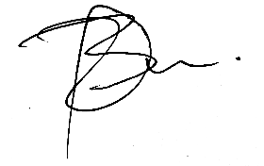
……………………………………………
MR. B.D LUKHELE
Director

